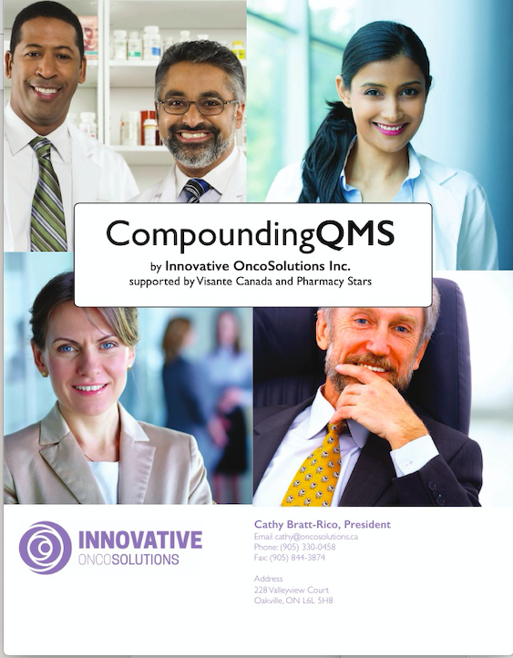

**CompoundingQMS™ User Requirements**

Innovative OncoSolution’s CompoundingQMS™ product offering is the result of years of experience in pharmacy audit and quality control and was built from the ground up as a totally electronic cloud-based audit and quality assurance system.

CompoundingQMS™ is the first and most customizable cloud-based solution incorporating best practices that address multiple quality, safety and compliance challenges of pharmacies. It replaces inefficient paper & spreadsheet compliance programs and less customizable web-based tools. The platform addresses all NAPRA guidelines including:

* **USP 797/ 800/ NAPRA compliance**
* **Drug Diversion**
* **Medication Storage**

Implementation is easy and straightforward. Whether it be self-audits, environmental monitoring and competency tracking for USP Chapters 797/ 800 and NAPRA, detection and prevention of drug diversion, tracking URAC compliance or ensuring safe and proper medication storage – clients can implement and start using CompoundingQMS™ in less than a week. No IT integration or support is required.

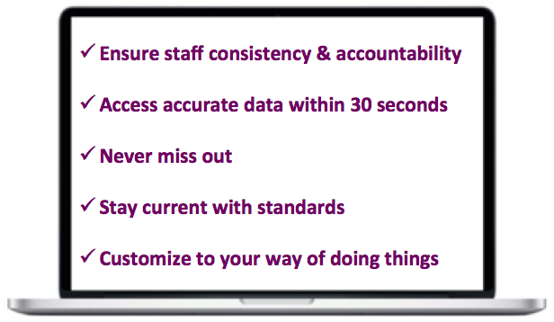

To assist in any Consulting Services and support as it relates to NAPRA compliance, IOS has a deep and close business relationship with Visante Canada, the premier pharmacy consulting company in Canada. IOS is able to bring the experience of Visante’s global pharmacy experts in USP 795, 797, 800, cGMP and NAPRA together to support any compliance issues related to these standards.

IOS offers a breadth of NAPRA expertise in design layout and we can also offer suggestions on your current workflow as it relates to NAPRA. We have been working with dozens of other hospitals engaged in NAPRA compliance and can share with you the rationale and decisions on how they have moved forward.

At a minimum, when looking at a NAPRA compliant Quality Management System solution, the following Mandatory and General Requirements should be evaluated:

